
NAME: RACHITHA.R
REG-NO: 192421058
SUBJECT: COMPUTER VISION FOR IMAGE SEGMENTATION
SUBJECT-CODE: ITA0528
DATE: 12.03.2026
EXPERIEMNT – 31
Code:
import cv2
img = cv2.imread("sample.jpg")
gray = cv2.cvtColor(img, cv2.COLOR_BGR2GRAY)
ret, thresh = cv2.threshold(gray, 127, 255, cv2.THRESH_BINARY)
cv2.imshow("Original", img)
cv2.imshow("Segmented Image", thresh)
cv2.waitKey(0)
cv2.destroyAllWindows()
Output:
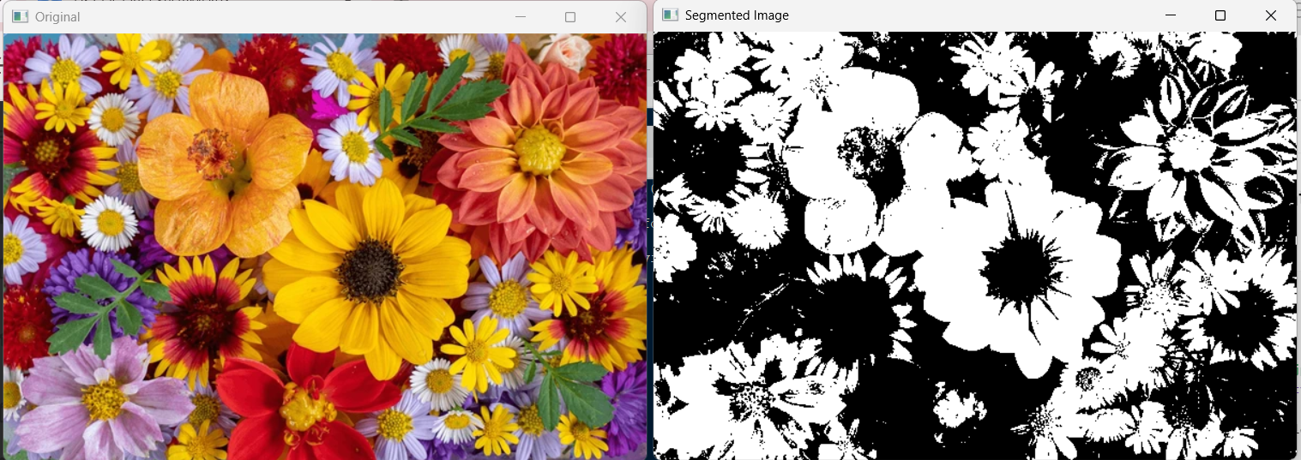

EXPERIMENT – 32
Code:
import cv2
import numpy as np
h = int(input("Enter height: "))
w = int(input("Enter width: "))
img = np.ones((h, w, 3), dtype=np.uint8) * 255
box_h = h // 10
box_w = w // 10
img[0:box_h, 0:box_w] = (0,0,0) # Black
img[0:box_h, w-box_w:w] = (255,0,0) # Blue
img[h-box_h:h, 0:box_w] = (0,255,0) # Green
img[h-box_h:h, w-box_w:w] = (0,0,255) # Red
cv2.imshow("Boxes", img)
cv2.waitKey(0)
cv2.destroyAllWindows()
Output:
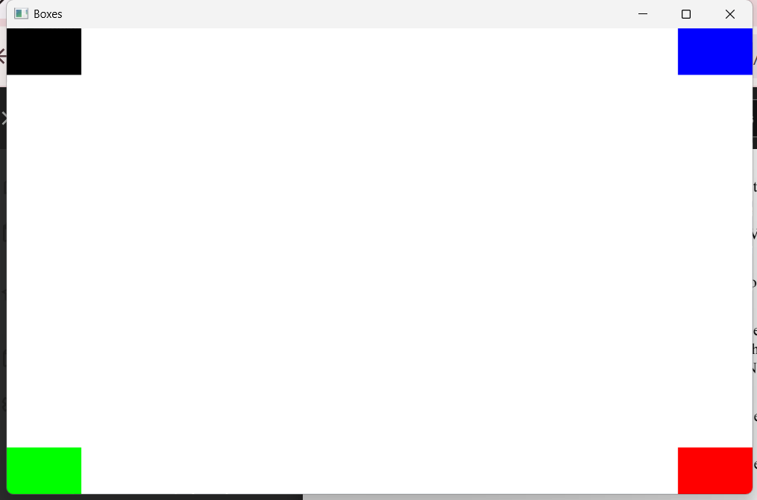

EXPERIMENT – 18
Code:
import cv2
import numpy as np
h = int(input("Enter height: "))
w = int(input("Enter width: "))
img = np.ones((h, w, 3), dtype=np.uint8) * 255
cv2.rectangle(img, (50,50), (200,150), (0,0,255), 3)
cv2.imshow("Rectangle", img)
cv2.waitKey(0)
cv2.destroyAllWindows()
Output:
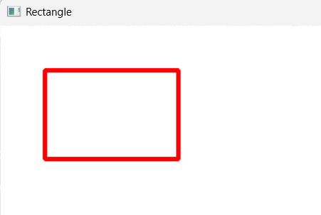

EXPERIMENT – 34
Code:
import cv2
import numpy as np
h = int(input("Enter height: "))
w = int(input("Enter width: "))
img = np.ones((h, w, 3), dtype=np.uint8) * 255
cv2.circle(img, (200,200), 100, (255,0,0), 3)
cv2.imshow("Circle", img)
cv2.waitKey(0)
cv2.destroyAllWindows()
Output:
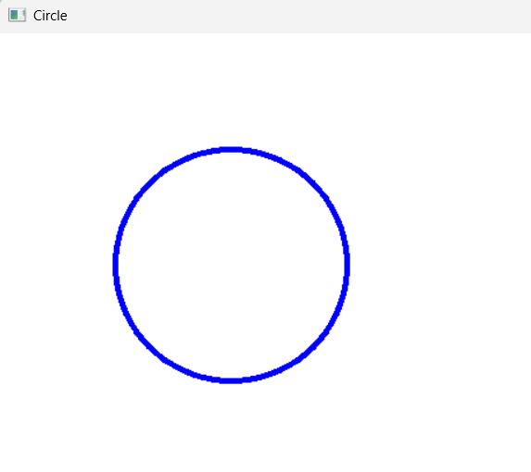

EXPERIMENT – 35
Code:
import cv2
import numpy as np
text = input("Enter text: ")
img = np.ones((400,600,3), dtype=np.uint8) * 255
cv2.putText(img, text, (50,200), cv2.FONT_HERSHEY_SIMPLEX, 1, (0,0,255), 2)
cv2.imshow("Text Image", img)
cv2.waitKey(0)
cv2.destroyAllWindows()
Output:
